**Intrepid Build**

Market Research Survey Outline

STAR



Maria Alejandra Jaramillo, Eli Dykes

March 28, 2024

**Title Page**

**Message to the community members:**

Thank you for taking the time to fill out this survey! You will be answering questions that will help us understand your housing needs, familiarity with high-strength steel homes, and overall demand for attainable housing options in the Chatham area.

For this survey's purpose, we define steel-framed homes as prefabricated homes (houses, apartments, townhouses, condos) built in a factory setting by putting together sections called “modules” made from steel containers. A steel-framed home does not look like a container, instead it utilizes steel containers to serve as the building framework for the home.

Attainable housing is defined as households that can spend more than 30% of their income on housing costs such as rent, mortgage, and utilities (e.g. households with $100,000 income combined). In essence, attainable housing is affordable and will not compromise quality and livability.

Please make sure to press "submit" when you reach the end of the survey. For questions or comments, email [Intrepidstar@kenan-flagler.unc.edu](mailto:Intrepidstar@kenan-flagler.unc.edu).

**Which best describes your relationship with Intrepid Build? (Select from dropdown below)**

* I am an Intrepid Build Employee
* I am an Intrepid Build Manager
* I am an Intrepid Build Community Partner/Corporate Partner
* I am not connected to Intrepid Build

**Demographic Information**

**1. What gender do you identify as?**

1. Male
2. Female
3. ________ (Short Answer Space)
4. Prefer not to say

**2. What is your age group?**

1. 18-24 years old
2. 25-34 years old
3. 35-44 years old
4. 45-54 years old
5. 55-64 years old
6. 65 years old and above
7. Prefer not to say

**3. Please specify your ethnicity (select all that apply)**

1. White/Caucasian
2. African American
3. Latino or Hispanic
4. Asian
5. Native American
6. Native Hawaiian or Pacific Islander
7. Two or More
8. Other/Unknown
9. Prefer not to say

**4. What is your current living situation?**

1. Own
2. Rent
3. Guest
4. Other ____________________ (Short Answer Space)

**5. Which of the following best describes your household?**

A. Living alone

B. Living with spouse/partner

C. Living with spouse/partner and children

D. Other______________________ (Short Answer Space)

**6. What is the highest degree or level of education you have completed?**

1. Some High School
2. High School
3. Some College
4. College
5. Some graduate
6. Post-graduate
7. Prefer not to say

**7. What is your annual household income?**

1. $0 - $24,999
2. $25,000 - $50,000
3. $50,000 - $80,000
4. $80,000 - $120,000
5. $120,000 - $150,000
6. $150,000 - $200,000
7. More than $200,000
8. Prefer not to say

**8. What is your current monthly housing cost? (excluding utilities, insurance, property tax, HOA fees, etc.)**

A. $0 - $499

B. $500 - $1,000

C. $1,001 - $2,000

D. $2,001 - $3,000

E. $3,001 - $4,000

F. More than $4,000

**9. What is your current employment status?**

A. Seeking Employment

B. Unemployed

C. Employed full-time

D. Employed part-time

E. Retired

F. Other _________________________ (short answer space)

**10. What is your Zip Code?**

Shape

**Housing Preferences & Priorities**

**1. When considering your next living arrangement, rank the following factors by moving each option in order of importance, 1 being most important (top) to 7 being least important (bottom).**

* Location (proximity to work, quality of schools, low crime rate, access to public transportation, future growth and development, proximity to green spaces)
* Price
* Size
* New Construction
* Eco-friendliness (energy-efficiency, high-quality insulation)
* Design customization options
* Community amenities (shops, daycare, restaurants, parks)

**2. What is your preferred type of housing? (Rank the following options, 1 being your least preferred and 5 being your most preferred)**

* Single-family
* Multi-family
* Townhouse
* Condo
* Apartment
* Modular

**3. What size of housing suits you best? (size options do not include garage, basement, or attic)**

A. Less than 600 sq ft (about twice the area of a parking space)

B. 600 – 1,000 sq ft

C. 1,000 – 1,500 sq ft (about half the area of a tennis court)

D. 1,500 – 2,000 sq ft

E. 2,000 – 2,500 sq ft

F. Over 2,5000 sq ft (about four times the area of a basketball court)

**4. Would you be willing to sacrifice having a large outdoor space (e.g. big yard) for the convenience of living closer to work, entertainment, and other daily needs?**

A. Yes

B. No

C. Maybe

**5. In your opinion, does high-density living offer sufficient options for families with children, in terms of space, amenities, and community resources?**

A. Yes

B. No

**6. Please briefly explain your answer to Question 5 in the space below.** Shape

**7. Do you care about how your home is constructed? (the building process behind your dwelling’s construction)**

* Yes
* No
* Indifferent

**8. If you answered “yes” to Question 7, please briefly explain why the building process behind your home’s construction matters to you?**

Shape

**Awareness and Perceptions of Steel-Framed Homes**

**1. How familiar are you with steel-framed homes?**

A. Very familiar

B. Somewhat familiar

C. Not familiar at all

**2. What is your perception of steel-framed homes compared to traditional stick-built homes?**

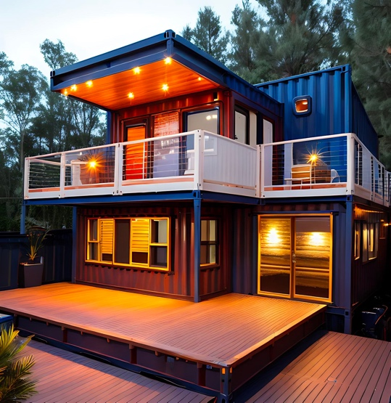 . 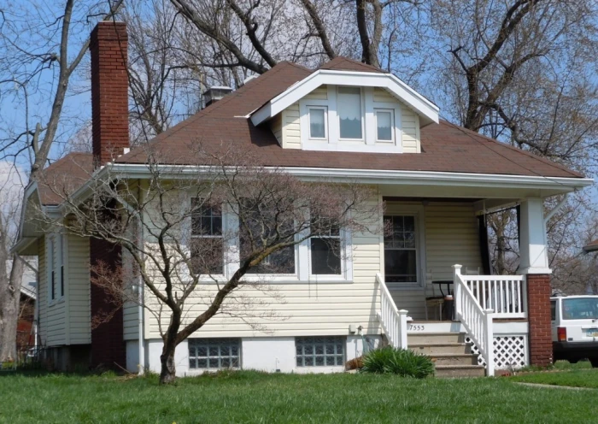

**STEEL-FRAMED HOMES STICK-BUILT HOMES**

|  |  |  |  |  |
| --- | --- | --- | --- | --- |
| Very  Unfavorable | Somewhat Unfavorable | Neutral | Somewhat Favorable | Very  Favorable |
| ☐ | ☐ | ☐ | ☐ | ☐ |

**3. How familiar are you with the benefits of having a steel-framed home vs a stick-built home?**

A. Very familiar

B. Somewhat familiar

C. Not familiar at all

**4. Steel-framed homes have multiple benefits. Please select all the benefits from the list below that are most appealing to you.**

* No mold
* Energy efficient
* Non-combustible
* Durable (structural integrity lends to longevity of the home)
* Customizable
* Low cost
* Sustainable/Eco-friendly (built out of recycled containers)
* Shorter construction time (built in a quality-controlled environment)

**5. Using steel containers (i.e. metal containers) as the building material for homes has many benefits. Please select all the benefits of metal from the list below you are most familiar with.**

* Minimal UV damage
* Fire resistant
* Pest resistant
* Air barrier/Thermal properties that benefit envelope performance
* Flexural strength (more flexible than wood alone)
* I wasn’t familiar with any of the benefits of metal as a building material

**6. Have you ever visited or lived in a steel-framed home? If yes, what was your impression? If you have not, please write N/A**

Shape

**Interest in Attainable Steel-Framed Homes**

**1. How likely are you to consider living in a steel-framed home (in your next purchase) if it met your needs and preferences?**

|  |  |  |  |  |
| --- | --- | --- | --- | --- |
| Very unlikely | Somewhat Unlikely | Neutral | Somewhat Likely | Very likely |
| ☐ | ☐ | ☐ | ☐ | ☐ |

**2. How much are you willing to spend per month on a steel-framed home?**

A. Less than $500

B. $500 - $1,000

B. $1,000 - $1,500

C. $1,500 – $2,000

D. $2,000 - $2,500

E. More than $2,500

**3. What concerns, if any, do you have about purchasing or living in a steel-framed home? (Select all the apply)**

* Quality and durability
* Resale value
* Financing options
* Design and customization limitations
* Stigma or perception
* Other ________________ (short answer space)

**4. Do you prefer townhomes to steel-framed homes?**

* Yes
* No
* Indifferent

**5. What amenities or features would make an attainable steel-framed home more appealing to you? (Rank 1 being most important (top) to 6 being least important (bottom))**

* 2+ bedrooms
* Energy-efficient windows
* Multiple bathrooms
* Customizable kitchen and living space
* Aesthetic exterior
* Other ________________ (short answer space)

**6. Would you buy or rent a home that was built utilizing steel containers as the framework? (The exterior look of the home would not look like a container)**

* Yes
* No
* Maybe

**7. Please briefly explain your answer to Question 6 in the space below (one to two sentences).**

Shape

**Claims Testing (For Steel-Frame Homes)**

***Please rate how strongly you agree or disagree with the statements below.***

**I value homes that are durable and long-lasting.**

|  |  |  |  |  |
| --- | --- | --- | --- | --- |
| Strongly disagree | Disagree | Neither agree  nor disagree | Agree | Strongly agree |
| ☐ | ☐ | ☐ | ☐ | ☐ |

**A home would be structurally weak and less durable if it used steel containers for the framework.**

|  |  |  |  |  |
| --- | --- | --- | --- | --- |
| Strongly disagree | Disagree | Neither agree  nor disagree | Agree | Strongly agree |
| ☐ | ☐ | ☐ | ☐ | ☐ |

**A home would be aesthetically unappealing if it used steel containers for the framework.**

|  |  |  |  |  |
| --- | --- | --- | --- | --- |
| Strongly disagree | Disagree | Neither agree  nor disagree | Agree | Strongly agree |
| ☐ | ☐ | ☐ | ☐ | ☐ |

**Steel-framed homes use low-quality materials for construction.**

|  |  |  |  |  |
| --- | --- | --- | --- | --- |
| Strongly disagree | Disagree | Neither agree  nor disagree | Agree | Strongly agree |
| ☐ | ☐ | ☐ | ☐ | ☐ |

**I would like a steel-framed home because they have quick construction times.**

|  |  |  |  |  |
| --- | --- | --- | --- | --- |
| Strongly disagree | Disagree | Neither agree  nor disagree | Agree | Strongly agree |
| ☐ | ☐ | ☐ | ☐ | ☐ |

**I would be more likely to consider steel-framed housing if there was more design flexibility.**

|  |  |  |  |  |
| --- | --- | --- | --- | --- |
| Strongly disagree | Disagree | Neither agree  nor disagree | Agree | Strongly agree |
| ☐ | ☐ | ☐ | ☐ | ☐ |

**I am skeptical of financing and insuring a steel-framed home in today’s market.**

|  |  |  |  |  |
| --- | --- | --- | --- | --- |
| Strongly disagree | Disagree | Neither agree  nor disagree | Agree | Strongly agree |
| ☐ | ☐ | ☐ | ☐ | ☐ |

**I know that high-strength steel-framed houses are well-made and competitive with other forms of attainable housing options.**

|  |  |  |  |  |
| --- | --- | --- | --- | --- |
| Strongly disagree | Disagree | Neither agree  nor disagree | Agree | Strongly agree |
| ☐ | ☐ | ☐ | ☐ | ☐ |

**I am aware of the cost-saving opportunity that prefabricated steel-framed housing creates.**

|  |  |  |  |  |
| --- | --- | --- | --- | --- |
| Strongly disagree | Disagree | Neither agree  nor disagree | Agree | Strongly agree |
| ☐ | ☐ | ☐ | ☐ | ☐ |

**I am skeptical of the industrial look of a prefabricated home.**

|  |  |  |  |  |
| --- | --- | --- | --- | --- |
| Strongly disagree | Disagree | Neither agree  nor disagree | Agree | Strongly agree |
| ☐ | ☐ | ☐ | ☐ | ☐ |

**I am aware that the exterior of steel-framed constructed homes can easily fit community aesthetic guidelines and/or can be customizable.**

|  |  |  |  |  |
| --- | --- | --- | --- | --- |
| Strongly disagree | Disagree | Neither agree  nor disagree | Agree | Strongly agree |
| ☐ | ☐ | ☐ | ☐ | ☐ |